**MINUTES OF THE ANNUAL GENERAL MEETING OF**

**Merryville Park Community Association – DP 270008**

held on Monday 24th November 2014 at the Murrumbateman Country Inn.

**Attendees:**

Belinda Tunks, Andrew Gorton, David Bray, Lesley Bray, David Manolas, Marlies Muscat, Leith Wintour, Jennifer Holland, Ari Holland, Judy Breen, Peter Long, Val Long, Tony Luke, Petra Luke, Vicky Wintour, Jemma Rice, Richard Howe, Marion Howe, Marc Blackmore, Marshall McGaughey, Carmel McGaughey, Juliet Brown, Stephen Brown and David Hogg.

**Apologies:**

Val Walker, Alan Walker, Peter Masters, Bella Masters, Andrew Muscat, Felicity Webb , Chris Webb, Richard Johnstone, Ron White and Airlie White.

Meeting opened at 7:30pm by Chairperson Judy Breen.

Minutes were sent out from previous general meeting.

Previous general meeting minutes were accepted by Peter Long and seconded by Leith Wintour.

**Proxies:**

Nil

**Chairperson’s Report:**

Welcome and thank you for coming to tonight’s AGM.

2014 has sped by and we now come again to the AGM for Merryville Park.

I would like to take this opportunity to thank the Committee for everything they have done this year for Merryville Park Community.

During the year we have had some maintenance work done around the estate including the usual mowing/slashing and spraying.

Also we have had work done on some of the trees on the estate. Pruning of higher branches and trees that obscured some of the bends on our roads was performed by O’Brien Tree Services and the old dead trees near the water tanks were also removed. This job has now been completed with the area being now cleared of the debris that remained.

We did have problems earlier in the year with the water pumps and thanks to the diligent work of the volunteers who take care of this area the pumps have been well serviced.

A number of properties change hands and we have welcomed some new lot holders to our community, and it is wonderful to see young families making their home in Merryville Park, Murrumbateman. It is a very good place to bring up children.

The dams are looking healthy, but with the very hot weather approaching, may I just give a reminder to be mindful of your water usage please.

Tonight’s AGM will see all the committee positions vacated and I would urge you to please consider a position on the Executive and committee members.

A special thank you to Richard Johnstone. He has a new job in Sydney that involves him travelling back and forth, so he won’t be standing this time round for the Treasurer position.

Accepted by Jennifer Holland and seconded by Carmel McCaughey.

**Secretary’s Report:**

**Correspondence since last meeting**

**Letter from Origin**

Electricity near Merryville Park entry gate. We have requested to turn off the power to that location.

**Letter from Department of Primary industries**

Office of water – bore and expiry of water supply due by 15th January 2015 $161.22 for the application - Bore License usage

**Sent out 2 section 26 certificates.**

* Lot 18 – sold and new people coming in.
* Lot 32 – sold and new people coming in

**Lot 32** - New owners - want to put on a granny flat – going to council and was sent the Management statement.

**Lot 47** - Dawn Sheridan - is building an animal shelter at the back – was situated OK– sent plans in to make sure covered off by the Management statement and that was fine.

Accepted by Marc Blackmore and seconded by Juliet Brown.

**Treasurer’s Report:**

Judy mentioned the below key points provided by Richard in his absence;

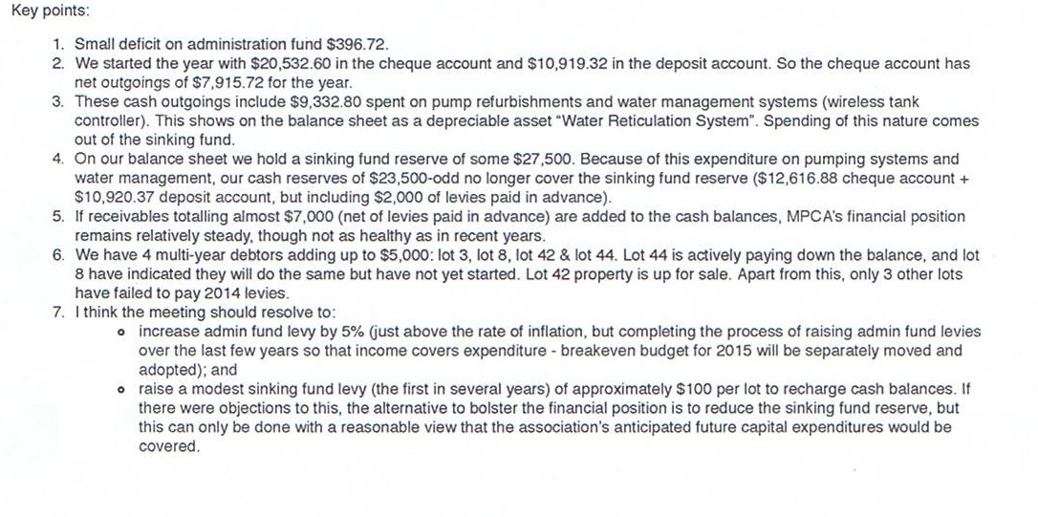**Levies:**

Vote on levies – to increase administration fund just above inflation rate by 5% so that income covers expenditure. This motion is put forward by the Treasurer.

All in favour of the 5% increase - Accepted

Accepted by Mark Blackmore and seconded by Judy Breen.

**Sinking Fund:**

Results for raising of the sinking fund;

* 12 - For
* 2 - Against

Motion carried as no requirement to have a unanimous vote.

Richard Howe accepted this and Val Long seconded the sinking fund.

It was raised to have the Sinking fund in its own account – Andrew Gorton will need to put that question to Richard the Treasurer.

**Budget:**

**Brief Overview of the Mowing contract with Stinson**

* We are locked in with the current contract until end of next year. It is a 3 year contract starting 1st January 2013. Fixed amount mowing, slashing around roads, dams, holding tanks. Prices go up by 5% per year. Price for mowing and slashing around 2 dams plus the holding tanks and verges $6,331.85. If 4th slash needed another $2,110.00.
* Spraying of all inaccessible areas – twice a year over $1,200.00.
* Mowing of all main culverts 3 times a year and the control of Patterson curse around the dams twice a year.
* 3 year with option of another 3 years if all parties satisfied. Contract price is for a calendar year.
* Mower and whipper snipping the front entrance. Done 5 times a year if necessary. $928.85 per year.

In a previous meeting Judy went out to see if anyone wanted to go and obtain a number of quotes.

Acacia Way – Trees have been pruned so mower can get under them. Stinson has asked that other dead branches and low branches be removed so that the mowers can get in and around safely. He has quoted for his staff to do the job $200 per hour. People have requested perhaps get an arborist like O’Brien’s in to quote and do the trees.

It was asked for an explanation of what Admin Fees referred to and consisted of and advised that would need to be responded to by Richard Johnstone, the Treasurer.

**Water Report December 2014:**

By Andrew Gorton

# Last 12 Months

Since the last AGM we have reread the water meters. General usage was within the 250 kilolitre allocation but there were a few estate residents who had used more than the allowance.

Last summer there was an issue with the bore which coincided with the failure of the pump on Dam 2 which left the estate without water. The holdup was getting repairs completed by Bungendore Rural.

Thanks to Mark Blackmore who moved the Pump from Dam 3 to Dam 2 which enabled pumping to resume.

A Smart_ Water tank level indicator was purchased back in February. This allows us to monitor the level of the main supply tank and adjust our pumping accordingly. The controller and the tank are connected via Wi-Fi, allowing constant monitoring of the tank.

We had a dry winter and spring this year and the water level in all dams is lower than we had hoped. Lot holders should again be prepared for short periods without water from the water system.

# Breakdowns

There were no broken pipes in the last 12 months. The pump on Dam 2 was refurbished with new components fitted. Good for another 25 years we hope.

All lot holders, especially those with toilets connected to the community water system should have a tank fitted to provide a few days of usage in case of breakdowns.

# The Bore

Since the AGM the bore pump and motor had to be replaced due to a failure of both components. The pump may have caused the motor to fail. Repairs were completed in January and since then it has been the main source of water for the estate.

# Current Situation

Over the winter our main water supply was mainly from the bore but with the recent hot weather pumping has resumed from the main pump at Dam 2.

# Maintenance

With lower dam levels the water quality has diminished. With pumping from the dam, the water has a small amount of silt which will block the filter. Lot holders should regularly check and clean the water filter located next to your meter

Access to meters is also a problem for the meter reader. Some meters boxes are over grown with grass or shrubs and others are full of dirt. Please ensure your meter is easily accessible.

Juliet Brown said to say thank you to Andrew for the running of the water for the estate.

On average the community water runs out once a week – perhaps for half a day.

Water Report Accepted by Stephen Brown and seconded by Jemma Rice.

**Election of Office Bearers**

**Chairperson:**

Richard Howe nominated for position of Chairperson by Andrew Gorton and seconded by Jemma Rice.

Position Accepted by Richard Howe

**Secretary:**

Marlies Muscat nominated for the position of Secretary by and seconded by Petra Luke.

Position Accepted by Marlies Muscat

**Treasurer:**

Marc Blackmore nominated for position of Treasurer by and seconded by Jemma Rice.

Position Accepted by Marc Blackmore

**Committee Members:**

Leith Wintour, Ron White, Peter Long, Val Long, Judy Breen, Lesley Bray, Andrew Gorton, Jemma Rice and David Hogg

**General Business**

**For Action:**

Nil

**Other business:**

* Note of appreciation for both Richard and Judy for their dedication to Merryville Park.
* David Bray to donate a water meter for Dam 3.
* David Minolas – advised he took water samples in of the dams and then they have since lost them. He will take in another lot of samples.

**Meeting Closed at 9:09pm.**

Next meeting is to be held on Monday 9th February 2015, at 7:30pm at Murrumbateman Country Inn.